Week 14 – Activity 4
The usage of decorator at WhānauWell projet
A new file, telemetry.decorator.ts, was integrated into the project. It contains a custom @Telemetry decorator designed to capture and log execution metadata to telemetry.log. Specifically, it records the method name, execution duration, and the outcome (success or error details).
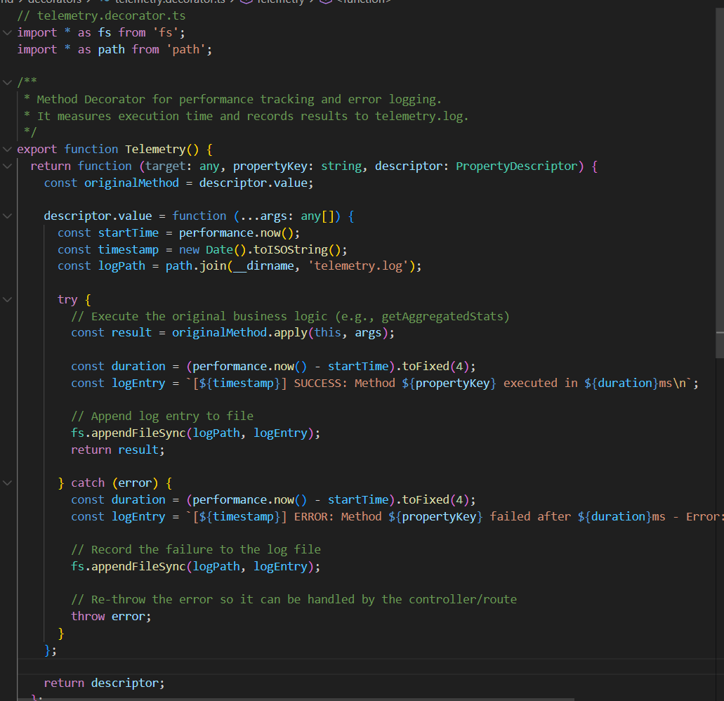
In the current scope, the decorator is applied to the getAggregatedStats method within the StressService. The primary advantage of this approach is its scalability and reusability; it can be effortlessly extended to monitor any existing or future services without duplicating logging logic or polluting the core business code.

